Stratfield Historic District Association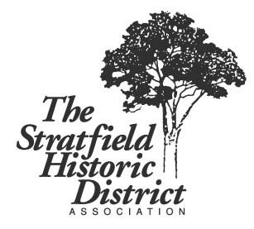
Meeting Notes – Nov. 9, 2020

In Attendance:
Margaret Judge
Steve Farrell
Linda Robak
Guy Horvath
Rev. Sara Smith
Steve Stafstrom
Ivelis Reyes
Susan Tabachnick
Milen Bedon
Diego Chachques

Meeting called to order at 7:38 p.m. Due to an issue with Linda’s Zoom connection and her inability to see members present, some who attended may not be noted above.
Linda read the minutes from October meeting. Susan motioned to accept minutes, Diego seconded. Motion passed.

Treasurer’s Report
There is currently $3,118.88 balance in the account as of today. Discussion ensued as to donating to help pay off the Farmer’s Market debt.

Update on Farmer’s Market by Rev. Sara
The final Farmer’s Market for 2020 was held at Stratfield Park on Oct. 3rd. Due to Covid-19 & orders from Gov. Lamont there were several restrictions all summer; no where to sit and stay/chat/eat, no activities for children other than arts & crafts they were given to take home, a reduced number of vendors, no live music until later in the summer, and while it ended with 250 shoppers on the last day, the crowds weren’t as large as last summer. Consequently, they are $1,000 in debt to pay back loan. (While it was hoped that money could be raised at a Winter Fair on Dec.5th, it had to subsequently be cancelled due to escalating Covid-19 cases.) Overall, under the trying circumstances, the market was still considered a success.

Monthly Clean-Up
Margaret reported only Kay showed up. Make sure you come out for the last one of the year on Dec. 12th at 9 a.m.

Sign
Judy did a mock up of the sign for everyone to view. Susan motioned to accept the design, Diego seconded. The approval meeting by the Parks department has yet to happen.

Historical Commission Update
Marcus Brown has reported that he submitted an Ordinance Amendment to the city legal department to merge the two Historic Commissions that was approved. There is still no plan in place for new commissioners and Susan will have to resign and then reapply to be on the commission as her term is up.

Christmas Tree Lighting Ceremony and Holiday Party
Cancelled for this year due to Covid-19, however the tree will still be lighted.

Sober House
Susan reached out to Paul Bouchet on Zoning/Health Dept. regarding the licensing of Sober House.

Next clean-up: Saturday, December 12th Next meeting: Monday, December 14th
Susan made motion to adjourn meeting; seconded by Linda. Meeting adjourned at 8:30 p.m.

